**Callum half-way:**

Hi Niels,

As discussed, I wrote this on my own since this is not an official feedback session, normally we collate multiple perspectives and have a 4-eyes check, but for a mid-term check-in I hope this helps you move forwards!

**Summary**

Niels, you've been a fantastic addition to the team through a combination of drive, helpfulness, capability and fun. You quickly build collaborative relationships with internal team members and external stakeholders, and you exhibit genuine interest & dedication in everything you're involved in.

With some more attention to protecting your own working time and workload, you'll ensure that you can sustain your effective & positive contribution to the team.

**Tops**

You easily jump into new topics & challenges - this adaptability & flexibility to work where you can be most useful is not only helpful but has been instrumental to the continued operation of the platform while we had staffing shortages and changing priorities. It demonstrates your committed attitude to working in a team and ambition to quickly learn things to get up to speed.

You reach out & ask lots of questions, and you're very easy-going & always challenge things objectively from a reflective & intellectual standpoint instead of e.g. arguing. These not only ensure we progress in the right direction but also fosters a collaborative & open dynamic.

You deliver results across a range of data & ML engineering topics - I sometimes forget that most of this is new to you because you're able to dive into the content to work across a wide tech stack and different capability layers.

You show interest in learning about processes as well as content, which will certainly help you later in your career but even now it means you are able to get more involved in higher-level discussions and share your perspective.

Your humorous & relaxed personality means it's always a pleasure to work & talk with you, and you bring this to the client too.

You're a clear communicator in one-to-one conversations - you provide context before diving into technical questions/content.

You work well with the client, they all quickly trusted your expertise (both the internal team and the wider stakeholder landscape) - both from a coding/implementation side as well as the decision-making & next steps side.

**Tips**

Protect your workload and push back on work.

Be sharp on what's important & urgent vs what can be left until tomorrow (or next week, or until the stakeholder chases up again) - use me & Leo to assess priority if needed.

You can also take off a few hours the next day if you worked late to deploy something urgent.

We can also change processes to facilitate this, e.g. leaving low-priority tickets unassigned until the higher priority tickets are done, or ensuring every refined ticket has story points to help determine workload.

Also, use the value case teams channel instead of directly trying to help, or escalate issues to me to decide if/when we tackle it - this helps protect the sprint so we can meet our deliverables.

Finally, just challenge me directly if I assign a ticket to you when you have a lot on your plate. If we don’t deliver, that's likely a problem with the team (staffing, priorities, over-promising, etc.) instead of your personal responsibility to work more hours.

You'll learn all about storylining & making nice slides in a bootcamp, but for now you can reach out for feedback to ensure you're delivering the key message. Good to think about what the audience should gain from this, and what we want from them (discussions & input, actions points & next steps). Your slides cover the content well, so now you can focus on adding the implications (i.e. the "so what?"), so that the audience knows what this means for them.

For design, Elmar is a great resource here. For key message & focus, me or Elmar can give some pointers (or anyone else who has followed the bootcamp).

Quick tip: I would also spend an afternoon researching Scrum & Agile to get a solid understanding of the process, which can bulk up your current knowledge and complement your content understanding.

Best regards,

Callum Cannadine

**Maarten:**  
  
Let me begin by stating that it is a pleasure to work together with Niels. A helpful, friendly and very knowledgeable teammember.

Tech skills

**Tops:**

* Works with all the best practices that we have implemented.
* Knows, or quickly learns, about different technologies (terraform, flyway, Docker, api's etc).
* Writes clean, maintainable and efficient code. Importantly, can critically look at code (both his own, as well as others').

**Tips:**

* I am not sure if you do this already, but organize a 'fast' notetaking sytem whenever you learn something technical. I use markdown files for this, and I copy paste snippets of code with some bullet points. In this way I can always go back to specific code snippets and I immediately understand the context.

Domain knowledge

**Tops:**

* Both being quite new to the feeld, I continue to be impressed by the non-technical things Niels knows from an organizational level. As example this includes his knowledge about various design choices for the platform, but also privacy restrictions and how they need to be taken into account during the technical work.

**Tips:**

* None.

Soft skills

**Tops:**

* Effective communication with stakeholders. Niels is able to clearly communicate technical topics towards people that have different levels of understanding. What is impressive is that he always manages to focus on the aspects of a topic that will influence his listeners *most*.
* Niels is extremely well prepared for any meeting he has. Often with notes, but more impressively with demos if he needs to get a complicated point across. Examples include demos of the new tagging system for deployment, or a new alerting system (among many).
* Turns out Niels is a good project manager. This I got to experience for the past month where he took over a great deal of Callums tasks.

**Tips:**

* Try to find the sweetspot when it comes to meeting preparation. What I mean by that is that it is not always beneficial to have the entire story 'written' out. This serves as practice for presentations that are not in front of a laptop screen, like sprint reviews etc. Try to limit the the cues to only 10 single bullet point (something I try to do).
* Fact that you are a good project manager, does not mean you have to be one. If you think this role does not suit you I think you can put that on the table and explain it to people why you want to focus less on this role.

Professional development

**Tops:**

* Learning mindset. Always trying to understand and learn from everything he is doing. This showed itself during work when we had to make a set of Docker images for our new solution. Niels was determined to understand the process of constructing them, looking at open source AWS code, internal documentation and asking plenty of questions. But I think the biggest testament to this is the fact that he is completing a degree in CS next to his work.
* Ad hoc voicing his preferences. I have often been impressed by how Niels can mention during sprint plannings the tickets he would like to work on because the topic interests him, and it falls out of his current domain on knowledge.

**Tips:**

* To juxtapose the previous top, I think Niels could be more vocal about his higher level interests. What he would like to focus on *during* a sprint, and not simply a single ticket to work on. His power is that he can do many things, data/ml/project_management. But I know he does not equally like all these things, and too much division of attention is not good. He can take a bigger role in guarding this, both for his own interest but in the end also for overal productivity as a team.

To end I want to reemphasize Nielss biggest strength: his helpfulness. It just takes a single peak in our support teams channel. If there would be a leaderboard closing threads (by solving support problems) Niels would be on top. He is always ready to help out with any problem. If he doesn't know the solution, you can always trust that he will figure it out and come back to you.

**Jacco:**

**Tops**

* Enorm slim; erg goed in het conceptueel begrijpen van nieuwe principes en je had snel een grip op nieuwe concepten.
  + Dit gaf veel vertrouwen wanneer ik een vraag stelde of jij iets op moest pakken dat je er wel uit zou komen en een oplossing zou vinden.
    - Dat maakt het erg fijn om met je samen te werken
* Breed geïnteresseerd en altijd leuk om mee te praten
* Goede can-do mentaliteit; je pakt problemen direct aan en handelt proactief

**Tips**

* Sommige taken kun je misschien iets gestructureerder aanpakken, om collega's te helpen met begrijpen waar je mee bezig bent en waar je staat.
  + Er staat me iets bij van het onderzoeken van Model Monitoring
    - Je had zelf een goed idee van hoe alles in elkaar stak en wat er mogelijk was, welke opties er waren etc. Maar er was niet echt een duidelijk overzicht van de voortgang / progressie op wat je had uitgezocht, dat maakte het in meetings waar het onderwerp ter sprake kwam lastig om mee te denken en te discussieren over de beslissingen.
    - Hier zou bijvoorbeeld een overzicht met alle pros/cons van elke tool en welke requirements er voor ons belangrijk zijn zou het team erg helpen als er discussies over zijn of beslissingen gemaakt moeten worden.

E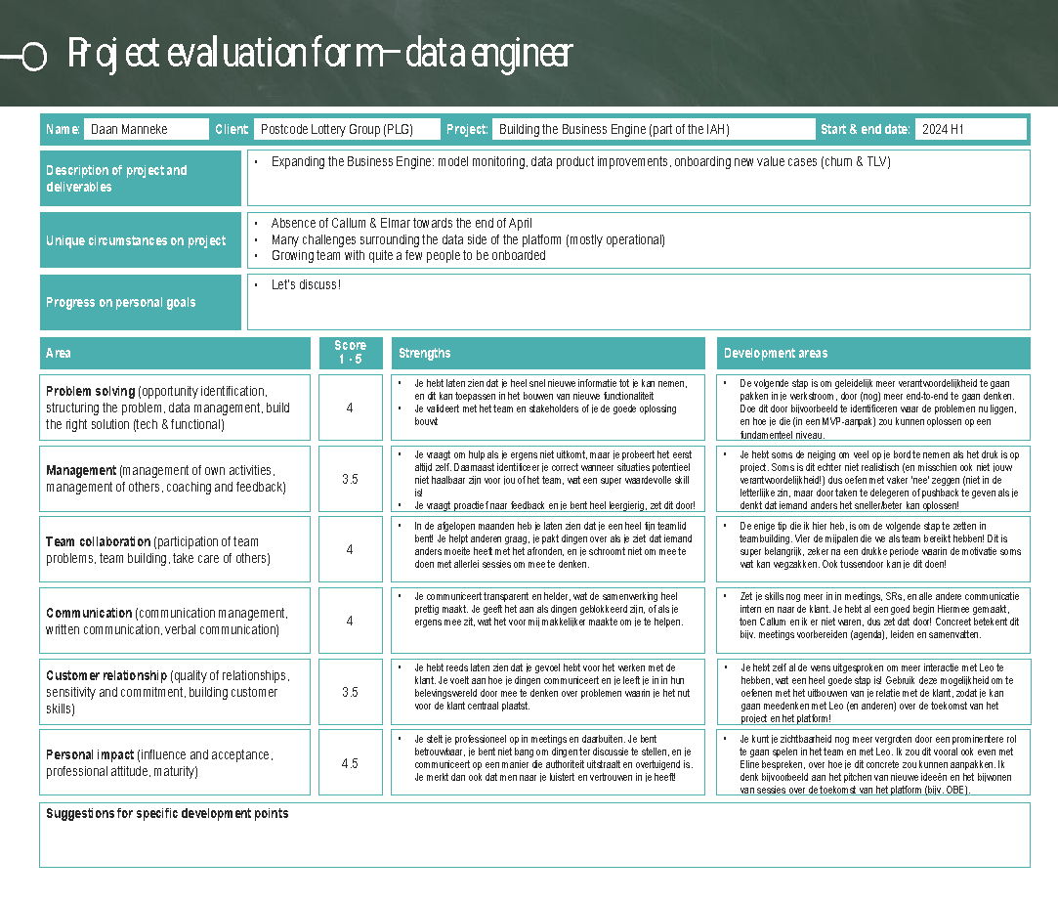

**Benedetta**

TOPS

* You are on top of everything, you know what is going on and what the deadlines are. You demonstrate good management skills of your own (and also of others) tasks
  + You have done a great job in this unclear period with many team changes in taking the lead and making sure that the whole team still works on what is relevant
* You have strong technical skills, can solve complex problems and also support others when they need your help
* You identify potential blockers and risks in time and communicate them clearly

TIPS

* You should try to ask more often for help/ask other people to step in. Sometimes you take on more than you should, while there are other people that can also take over some work from you, such that you can focus on what is relevant for you

**Frejanne**

**Frejanne voor Niels - op basis van wekelijkse interne team check-ins rond het data producten & data&ML platform PLG team**

Strengths

* Durft uitdagingen in project context aan te kaarten en challengt richting/beslissing die 'bovenin' wordt genomen - blijf hiermee oefenen en leren wanneer het wel en niet effectief is
* Bezig met hoe team set-up 'gaat werken' (bewust van belang hiervan) - gebruik dit in kleine settings en ga dit langzaam uitbouwen
* Stroopt mouwen op om dingen gedaan te krijgen - je hebt heel knap het team en werkstromen gaande gehouden in de leegte die ontstond rond plotselinge vertrekken en afwezigheden van team members aan PLG en Rewire kant

Visible improvements

* Inhoudelijk fors gegroeid als ik kijk naar wat voor tickets/epics je op je naam hebt - kwaliteit vind ik lastiger inschatten, zit sowieso goed, maar weet niet hoe goed
* Zelfstandigheid enorm gegroeid - weet in PLG landschap te navigeren en is begonnen met ook iemand onder hoede te nemen (WS Jochem)

Tips

* Wanneer pak je wel en niet ownership en welk effect heeft dit op je omgeving en jezelf - ik denk dat je hier veel ruimte voor verbetering hebt, met name om jezelf te beschermen en focus te geven en daarmee ook om anderen te leren hun rollen goed te pakken
* Grenzen aangeven als je doorhebt dat je een 'verkeerde' richting in geduwd wordt - leren denken in rollen, welke rol heb jij en past iets dat wordt voorgesteld dat jij gaat doen daarbij?
* Volgende stappen zetten op technische topics - je hebt hier nog genoeg dingen te leren (zowel in de keten van design tot succesvol deployen als in de breedte van type engineering/producten), durf ik te zeggen op basis van je tenure